# **Assignment on Network Configuration**

**Name: *Adarsh Srivastava***

**Pursuing: *Masters in Cloud Computing***

**Batch: *11 to 1 PM***

**Enrollment No.: *JKENRSX11126***

**Instructor: *Sunny Sir***

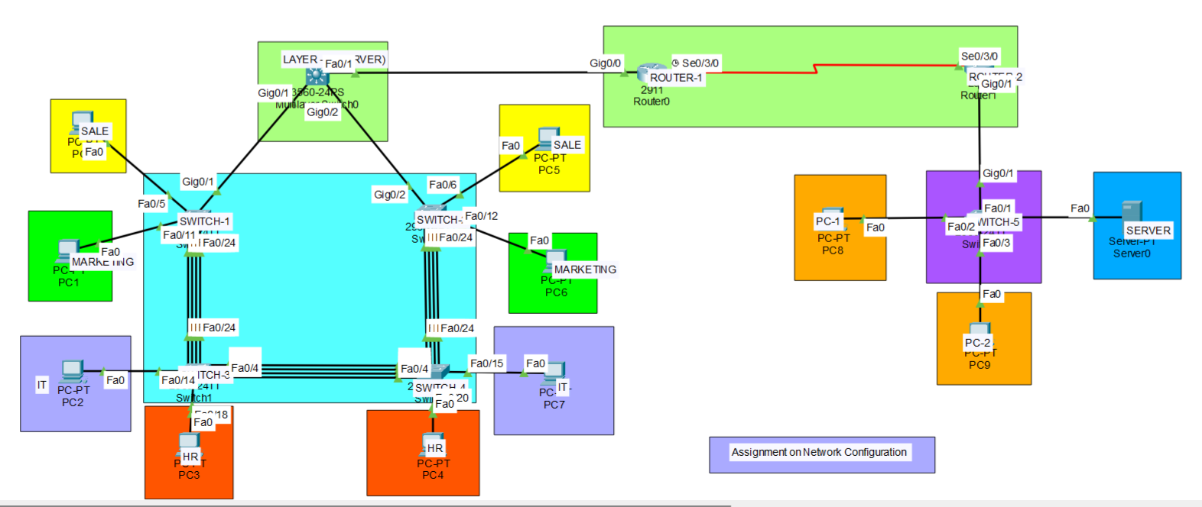

**Step by Step Network Configuration**

**Objective: To configure a network with VLANs, Inter VLAN routing, VTP, EtherChannel, Spanning Tree Protocol, and EIGRP to ensure connectivity and communication between all devices.**

**Basic Configuration (on Layer -3 Switch and Switch 1,2,3,4)**

**On Layer 3 Switch**

**-----------------------------------------**

* **enable**
* **conf t**
* **hostname L3-Switch**
* **enable secret Adarsh**
* **username Adarsh password 123**
* **ip domain-name lab.in**
* **crypto key generate rsa**
* **1024**
* **ip ssh version 2**
* **line vty 0 5**
* **login local**
* **transport input all**
* **password 456**

**-----------------------------------------**

**On Layer 2 Switch - 1**

**-----------------------------------------**

* **enable**
* **conf t**
* **hostname L2-Switch1**
* **enable secret Adarsh**
* **username Adarsh password 1234**
* **ip domain-name lab.in**
* **crypto key generate rsa**
* **1024**
* **ip ssh version 2**
* **line vty 0 5**
* **login local**
* **transport input all**
* **password 456**

**------------------------------------------**

**On Layer 2 - 2**

**------------------------------------------**

* **enable**
* **conf t**
* **hostname L2-Switch2**
* **enable secret Adarsh**
* **username Adarsh password 12345**
* **ip domain-name lab.in**
* **crypto key generate rsa**
* **1024**
* **ip ssh version 2**
* **line vty 0 5**
* **login local**
* **transport input all**
* **password 456**

**------------------------------------------**

**On Layer 2 - 3**

**------------------------------------------**

* **enable**
* **conf t**
* **hostname L2-Switch3**
* **enable secret Adarsh**
* **username Adarsh password 123456**
* **ip domain-name lab.in**
* **crypto key generate rsa**
* **1024**
* **ip ssh version 2**
* **line vty 0 5**
* **login local**
* **transport input all**
* **password 456**

**-------------------------------------------**

**On Layer 2 - 4**

**-------------------------------------------**

* **enable**
* **conf t**
* **hostname L2-Switch3**
* **enable secret Adarsh**
* **username Adarsh password 1234567**
* **ip domain-name lab.in**
* **crypto key generate rsa**
* **1024**
* **ip ssh version 2**
* **line vty 0 5**
* **login local**
* **transport input all**
* **password 456**

**Step 1: Create Trunks Between Layer3 and Layer2 Switches**

**1. Layer3 Switch (VLAN1):**

* **interface range fa0/1-24**
* **switchport mode trunk**
* **switchport trunk encapsulation dot1q**

**2. Layer2 Switches (VLAN10, VLAN20, VLAN30, VLAN40):**

* **interface range fa0/1 -24**
* **switchport mode trunk**
* **switchport trunk encapsulation dot1q**

**Step 2: Create EtherChannel Between Layer2 Switches**

**1. VLAN10 and VLAN 20:**

* **interface range fa0/21-24**
* **channel-protocol pagp**
* **channel group 1 mode desirable**
* **interface po1**
* **switchport mode trunk**

**2. VLAN 20 and VLAN 30:**

* **interface range fa0/21-24**
* **channel-protocol lacp**
* **channel group 1 mode active**
* **interface po1**
* **switchport mode trunk**

**3. VLAN 30 and VLAN 40:**

* **interface range fa0/1-4**
* **channel-protocol lacp**
* **channel group 1 mode active**
* **interface po1**
* **switchport mode trunk**

**Step 3: Configure VTP Server on Layer3 Switch**

**1. Layer3 Switch:**

* **vtp mode server**
* **vtp domain lab**
* **vtp password 123**

**Create VLANs:**

* **vlan 10**
* **name SALES**
* **vlan 20**
* **name MARKETING**
* **vlan 30**
* **name HR**
* **vlan 40**
* **name IT**

**Configure VTP Client on layer-3 switches**

* **vtp mode Server**
* **vtp domain lab.in**
* **vtp password 123**
* **int range f0/5-10**
* **switchport access vlan 10**
* **int range f0/11-13**
* **switchport access vlan 20**
* **int range f0/14-16**
* **switchport access vlan 30**
* **int range f0/17-20**
* **switchport access vlan 40**

**Step 4: Configure VTP Clients on Layer-3 Switches and Assign Ports to VLANs**

**1. VLAN 10:**

* **vtp mode client**
* **vtp domain lab.in**
* **vtp password 123**
* **interface range fa0/5-10**
* **switchport mode access**
* **switchport access vlan 10**

**2. VLAN 20:**

* **vtp mode client**
* **vtp domain lab.in**
* **vtp password 123**
* **interface range fa0/11-13**
* **switchport mode access**
* **switchport access vlan 20**

**3. VLAN 30:**

* **vtp mode client**
* **vtp domain lab.in**
* **vtp password 123**
* **interface range fa0/14-16**
* **switchport mode access**
* **switchport access vlan 30**

**4. VLAN 40 root Switch:**

* **vtp mode client**
* **vtp domain lab.in**
* **vtp password 123**
* **interface range fa0/17-20**
* **switchport mode access**
* **switchport access vlan 40**

**Step 5: Configure Rapid PVSTP on Every VLAN**

**1. Layer 3 Switch:**

* **Spanning-tree mode rapid-pvst**
* **Spanning-tree vlan 14094 priority 4096**

**2. Layer 2 Switches:**

* **Spanning-tree mode rapid-pvst**
* **Spanning-tree vlan 14094 priority 8192**

**Step 6: Assign IP Addresses on End User Devices**

**Vlan -10**

**SALE**

**IP - 192.168.1.2**

**Subnet- 255.255.255.192**

**Default Gateway - 192.168.1.1**

**DNS Server - 172.168.1.100**

**MARKETING**

**IP - 192.168.1.67**

**Subnet- 255.255.255.224**

**Default Gateway - 192.168.1.1**

**DNS Server - 172.168.1.100**

**Vlan -20**

**SALE**

**IP - 192.168.1.3**

**Subnet- 255.255.255.192**

**Default Gateway - 192.168.1.1**

**DNS Server - 172.168.1.100**

**MARKETING**

**IP - 192.168.1.68**

**Subnet- 255.255.255.224**

**Default Gateway - 192.168.1.1**

**DNS Server - 172.168.1.100**

**Vlan -30**

**HR**

**IP - 192.168.1.98**

**Subnet- 255.255.255.240**

**Default Gateway - 192.168.1.1**

**DNS Server - 172.168.1.100**

**IT**

**IP - 192.168.1.114**

**Subnet- 255.255.255.248**

**Default Gateway - 192.168.1.1**

**DNS Server - 172.168.1.100**

**Vlan -30**

**HR**

**IP - 192.168.1.99**

**Subnet- 255.255.255.240**

**Default Gateway - 192.168.1.1**

**DNS Server - 172.168.1.100**

**IT**

**IP - 192.168.1.115**

**Subnet- 255.255.255.248**

**Default Gateway - 192.168.1.1**

**DNS Server - 172.168.1.100**

**Step 7: Configure Inter VLAN Routing on Layer3 Switch**

**1. Layer3 Switch:**

* **int vlan 10**
* **ip add 192.168.1.1 255.255.255.192**
* **no shut**
* **int vlan 20**
* **ip add 192.168.1.65 255.255.255.224**
* **no shut**
* **int vlan 30**
* **ip add 192.168.1.97 255.255.255.240**
* **no shut**
* **int vlan 40**
* **ip add 192.168.1.113 255.255.255.248**
* **no shut**

**Step 8: Assign IP Addresses on Layer3 Switch & Routers**

**1. Layer3 Switch:**

**int vlan 1**

**ip add 10.10.10.5 255.255.255.252**

**no shut**

**2. Router0:**

**int g0/0**

**ip add 10.10.10.1 255.255.255.252**

**no shut**

**int s0/3/0**

**ip add 10.10.10.6 255.255.255.252**

**no shut**

**3. Router1:**

**int g0/1**

**ip add 10.10.10.3 255.255.255.252**

**no shut**

**int s0/3/0**

**ip add 10.10.10.5 255.255.255.252**

**no shut**

**Step 9: Configure EIGRP Routing**

1. **Layer3 Switch:**

**Ip routing**

**router eigrp 1**

**net 192.168.1.0**

**net 192.168.1.64**

**net 192.168.1.96**

**net 192.168.1.112**

**net 10.10.10.4**

**2. Router0:**

**router eigrp 1**

**net 10.10.10.1**

**net 10.10.10.4**

**net 10.10.10.6**

**3. Router1:**

**router eigrp 1**

**net 172.168.0.0**

**net 10.10.10.1**

**net 10.10.10.4**

**Server**

**IP – 172.168.1.100**

**Subnet Mask – 255.255.255.0**

**Default Gateway – 172.168.1.1**

**DNS – 172.168.1.100**

**Step 10: Check Connectivity**

**1. Ping from PC1 (SALE) to PC2 (MARKETING):**

ping 172.16.20.10

**2. Ping from PC1 (SALE) to Server (Server0):**

ping 172.16.1.100

**3. Ping from PC4 (IT) to PC3 (HR):**

ping 172.16.30.10